**Q1**

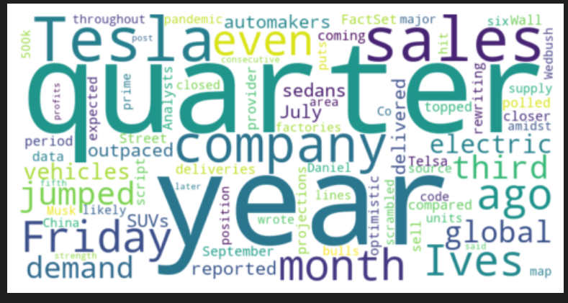

**Q2**

Sentiment score = 0.010869565217391304

**Q3**

Fog index = 13.389473684210527

**Q4**

a)

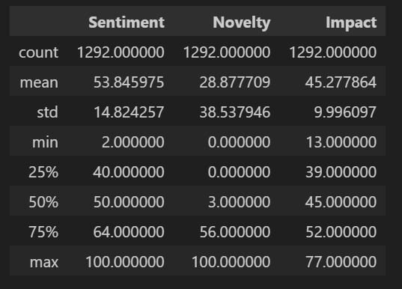

b)

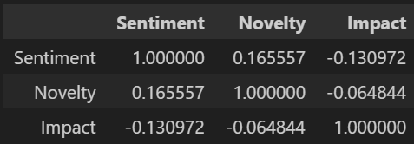

c)

